**HETERO ASSOCIATIVE MEMORY NETWORK**

**Architecture**

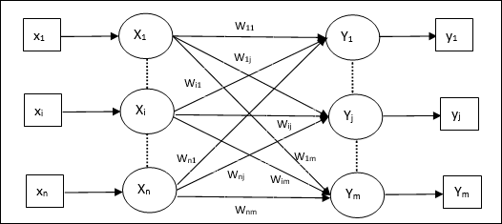

**Training Algorithm**

For training, this network is using the Hebb or Delta learning rule.

**Step 1** − Initialize all the weights to zero as **wij = 0***i*=1*ton*,*j*=1*tom*i=1ton,j=1tom

**Step 2** − Perform steps 3-4 for each input vector.

**Step 3** − Activate each input unit as follows −

*xi*=*si*(*i*=1*ton*)xi=si(i=1ton)

**Step 4** − Activate each output unit as follows −

*yj*=*sj*(*j*=1*tom*)yj=sj(j=1tom)

**Step 5** − Adjust the weights as follows −

*wij*(*new*)=*wij*(*old*)+*xiyj*wij(new)=wij(old)+xiyj

**Testing Algorithm**

**Step 1** − Set the weights obtained during training for Hebb’s rule.

**Step 2** − Perform steps 3-5 for each input vector.

**Step 3** − Set the activation of the input units equal to that of the input vector.

**Step 4** − Calculate the net input to each output unit **j = 1 to m;**

*yinj*=∑*i*=1*nxiwij*yinj=∑i=1nxiwij

**Step 5** − Apply the following activation function to calculate the output

*yj*=*f*(*yinj*)=⎧⎩⎨⎪⎪+10−1*ifyinj*>0*ifyinj*=0*ifyinj*<0